FOREWARD

Thank you for your interest in proposing for Cabaret Theatre’s 2015-2016 season.

Since 1975, Cabaret Theatre has created its season based on the proposals of creative and driven directors. Without artists like you, Cabaret would not have its reputation as one of the best student theatre companies at Rutgers University. We are excited to produce yet another season of innovative and professional quality productions and to continue to expand our mission of education and collaboration.
The Reading Committee is now accepting proposals for the upcoming season. Guidelines are enclosed in this packet. Included are six (6) sections to be completed by June 1, 2016; to ensure a timely response, please be sure to check and double check your proposal for all the necessary components before submission.

First, we request an email to artistic.cabarettheatre@gmail.com and cc’ed to producer.cabarettheatre@gmail.com, and ata49@scarletmail.rutgers.edu as soon as possible letting us know that you are interested in proposing. If you would like to include the show(s) you are considering proposing, that is perfectly acceptable; however, this preliminary email does not attach you to any specific show.

All proposals will go through a two-tiered process of evaluation. If your proposal continues to the second stage, you will be asked to schedule an interview with the Executive Board and Gen Board Representative to complete the proposal process. We will provide a detailed document including what to expect during the interview should your proposal be selected for further discussion. Those invited to interview should expect to do so on July 13, 2015 and July 14, 2015.

Finally, if you have any questions or concerns about the proposal process, do not hesitate to contact the Producer (producer.cabarettheatre@gmail.com) or the Artistic Director (artistic.cabarettheatre@gmail.com).

We look forward to your proposal!

Sincerely,

The Reading Committee
Cabaret Theatre
2015-2016

THE READING COMMITTEE

The Reading Committee consists of three members: the producer, the artistic director, and the general board representative. In the event you should need to contact one of the readers, please reference the information listed below:

Title | Name | Email
Producer | Kayla Votapek | producer.cabarettheatre@gmail.com
Artistic Director | Eddie Norgard | artistic.cabarettheatre@gmail.com
General Board Representative | Alex Albanese | ata49@scarletmail.rutgers.edu

WHAT ARE WE ACCEPTING PROPOSALS FOR?

Cabaret Theatre is currently accepting proposals for the entire 2015-2016 Season, meaning both the Fall and Spring semesters. You may specify which semester you prefer in Section 1 of the packet.

Please note we are only accepting submissions from any full-time or part-time Rutgers New Brunswick University undergraduate students. To confirm this, everyone must provide an RUID number with their proposal. Due to University constraints, we will not consider any proposals by non-students or non-undergraduates.

Typically productions at Cabaret Theatre fall into two categories: Main stage productions (show usually runs 2 weekends) and Special Projects (show usually runs 1 weekend). This proposal packet is for Main stage productions; those interested in working on a Special Project should contact the Producer.

If the production you are proposing is an original play, please indicate as such in your proposal. For a full-fledged main stage production, the director should be the person proposing the production. If the playwright is interested in having their play worked on as a Special Project, they should contact the Producer to discuss options. Original plays must have been written by Rutgers University undergraduate students to be considered. A finalized version of the script, ready for production, must be included with the proposal.

Finally, if you are looking for Cabaret Theatre to host a non-theatrical event that is not bound to a script, please contact our Producer at the email above. This proposal packet is solely for theatrical productions.

GUIDELINES & REQUIRED INFORMATION

Organization and professionalism are important qualities to demonstrate when proposing to fulfill a leadership position such as a director. To ensure that your proposal reflects your level of commitment, please consider the formatting, grammar, spelling, and presentation of your composition.

The following materials are required to complete your submission:

- THREE (3) hard copies and ONE (1) electronic copy of the proposal form, consisting of the following sections:
  - Section 1: Cover Letter
  - Section 2: Introduction
  - Section 3: Artistic Vision
  - Section 4: Budget
  - Section 5: Staff
  - Section 6: Theatrical Resume(s)
- THREE (3) hard copies of the COMPLETE script of your proposed show.
- ONE (1) CD copy of the musical score or include a link/mp3 in the e-mail of the electronic proposal submission (only if you are proposing a musical).

SUBMISSION DEADLINE

All three hard copies of the proposal and script (and CD if necessary) should be included in one envelope or package. Proposals should be postmarked no later than May 30, 2015. Late submissions will not be accepted.

Please send proposals to the below address before the June 1st, 2015 :

Kayla Votapek
143 Dunellen Ave.
Dunellen, NJ 08812

If you would rather drop off your proposal to avoid shipping cost, contact the Producer to schedule a meeting time within the New Brunswick area.

Electronic copies should be sent to artistic.cabarettheatre@gmail.com and CC’ed to producer.cabarettheatre@gmail.com and ata49@scarletmail.rutgers.edu

REQUIRED INFORMATION WALK THROUGH

Section 1.Cover Letter

The cover letter should include three components:
- A brief description of your connection to the play you are proposing (200 words max)
- A description of your leadership style (2000 words max)
- A personal “snapshot”: tell us a little about yourself (your interests, your involvement). Don’t just limit yourself to discussing theatre. If you are selected to direct a production, the executive board will be working closely with you for a number of months. Tell us about yourself now.

Things to consider while writing: Cabaret Theatre is the only Rutgers theatre group to give non-E-Board members the opportunity to propose shows that you would direct this season. We work hard to provide talented students with a forum to express themselves and we want to know why this appeals to you. We are also interested in why you should be selected to direct. What are your leadership qualifications (in theatre and/or outside of theatre)? What is your problem solving style? How comfortable are you with collaboration? Share with us some instances in which you have worked with a large group in a leadership role and you were successful; or, if not successful, tell us what you would have done differently. If your proposal moves on to the interview stage, you will be asked many questions about your leadership potential and your ability to collaborate with others. We are very excited to get to know you and this cover letter is the perfect opportunity to give us a snapshot of your leadership potential. Save the artistic discussion for a later section. For this part, tell us HOW you would direct.
Section 2. Introduction

Please include the following information in a presentable format:

- Contact Information
  - Name
  - Address
  - Email
  - Primary Phone Number
- Personal Information:
- Age
- Class Year
- RUID Number
- Are you a part-time or full-time student?
- Schedule Information:
  - Please include any/all information about your schedule for the 2015-2016 academic year.
  - Include possible school/work schedules/study abroad plans as well as any familial or other organizational restraints.
  - Please include if you are in a leadership position for any other student organization (Ex. Business Manager for Glee Club, President of Kirkpatrick Choir, etc.)
- Opening Statement
  - In a few sentences, please describe the show you are proposing for the 2015-2016 Season.
Please Include:
      - The full title of the Show.
      - Any necessary author or creative credits.
      - The suggested place in season (Fall or Spring Semester) and why it should be placed there.
- Also attempt to categorize the genre of your proposal by answering these questions:
  - In what kind of location or setting does the production occur in?
(Contemporary, Crime, Historical, Science Fiction, Sports, War, Western, etc.)
  - What is the overall mood or tone of the production?
(Action, Adventure, Comedy, Drama, Farce, Mystery, Absurdist, etc.)
  - What is the age appropriateness of your production?
(Our talent pool and audience is primarily college students; how could you make it work for your show?)

Section 3. Artistic Vision

Your artistic vision is the crux of your proposal. You should include all the components in the pyramid listed below; however, we are not looking for a general list that answers each step. Use the bottom-up approach to craft your vision and compose several paragraphs as you would an academic essay.
Use your voice to your advantage; this is an excellent opportunity for the Reading Committee to get to you know you beyond your standard biographical information.
Please note, we are particularly interested in productions that keep the theatrical space in mind; Cabaret Theatre is the only student-run black box theater on campus how does your vision plan on taking advantage of the space? In other words, we are looking for proposals that defy the conventional “static interior” type productions more suitable to proscenium stages.

If at any time you are finding trouble in explaining a portion of your artistic vision, you may include a short video or audio recording to explain yourself further. Please limit your multimedia portion to 5 minutes. You may focus on one portion of your proposal ONLY within your multimedia submission (Ex. you may want to explain your set through a video but then you cannot explain any other portion of this packet). A multimedia submission is optional and will not affect whether or not your proposal moves onto the next tier. Submitting a video or audio recording to explain a specific section, however, does not exclude you the requirement of attempting to write that portion out.

***NOTE: Please feel free to e-mail the Artistic Director with any questions regarding your artistic vision. Please CC both the Producer and Gen Board Representative when doing so. It can be particularly difficult to develop an in depth vision such as pushing past basic themes like “love” or “identity.” If you are struggling, you may pose general questions to help resolve any conflicts or “writer’s block”. The Artistic Director, however, may decline to answer any questions that may lead to an unfair advantage in creating a proposal.

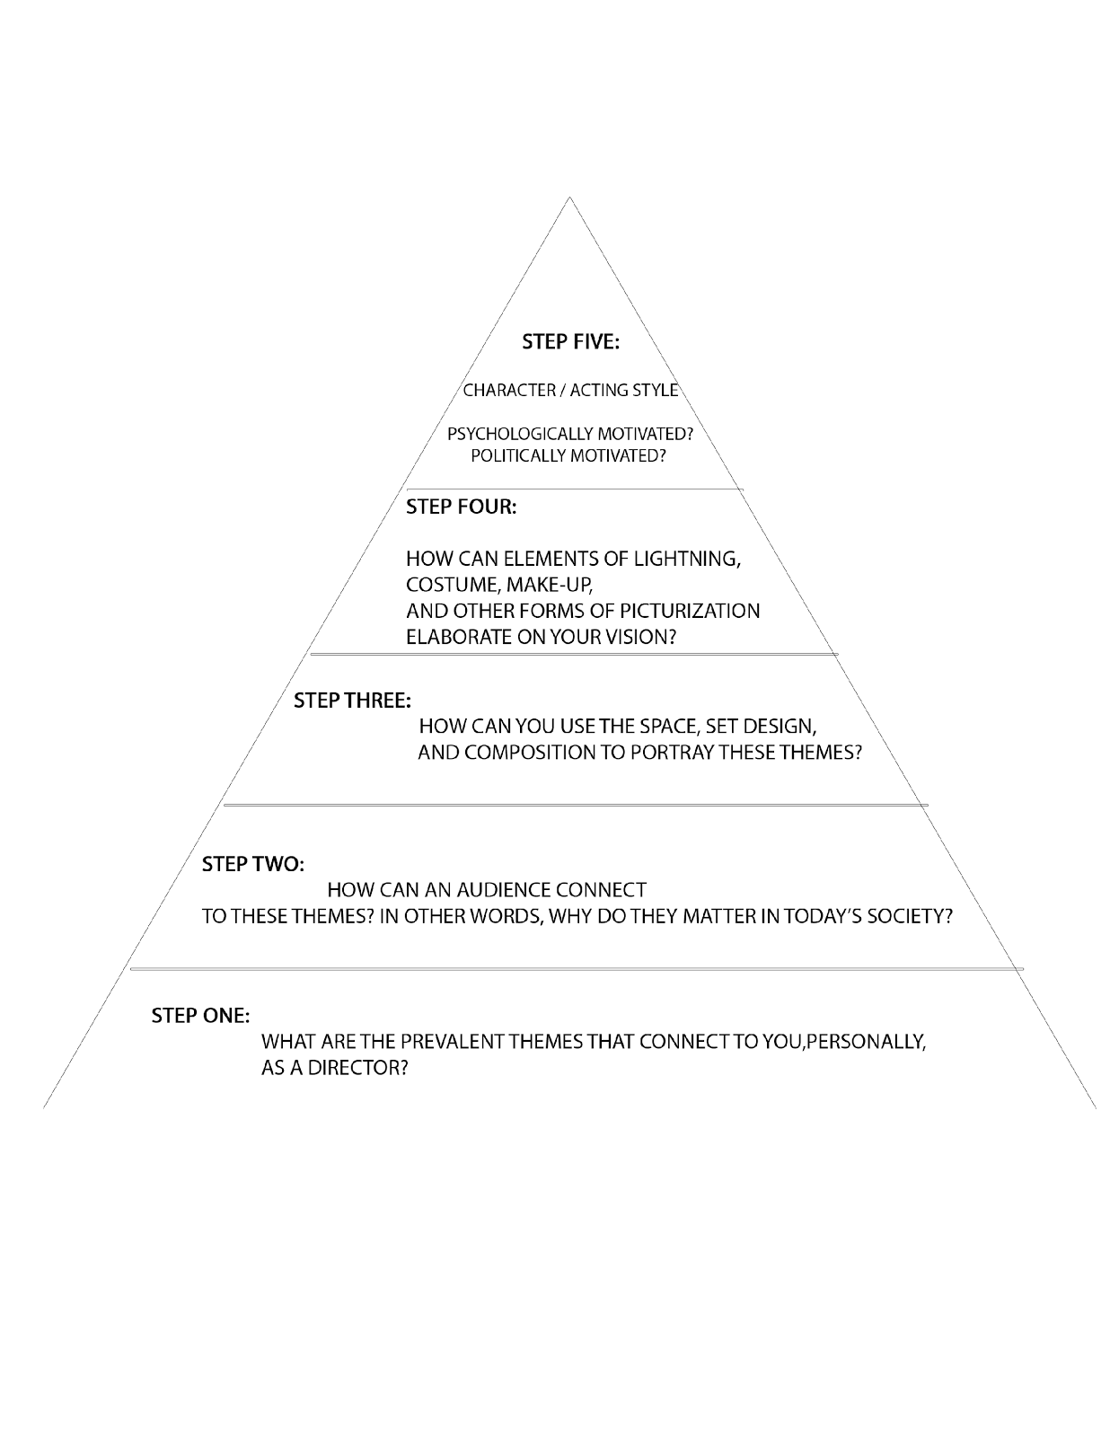

Section 4. Budget

The majority of budget discussion will take place during the second tier of the proposal process. However, we do ask for you to provide the royalty costs of the show you are proposing.

Licensing information can traditionally be found at:

- Dramatists Play Service, Inc. (http://www.dramatists.com)
- Samuel French, Inc. (http://www.samuelfrench.com/store)
- Music Theatre International (http://www.mtishows.com)
- Theatrical Rights Worldwide (http://www.theatricalrights.com)

Please list the name of the license service, the price per show, and any other potential costs regarding rights.

Finding royalty costs can be somewhat complicated, particularly for musicals—if you need help or have any questions, please contact the Producer or Artistic Director.

Section 5. Staff

In this section, please provide the names and positions of individuals you plan to have on your production staff. As this is a proposal, the Reading Committee understands that this is a tentative staff. However, please consult individuals before attaching their names to a proposal.

Also note that if selected, your final production staff will ultimately be at the discretion of the Executive Board. In order to maintain our mission statement, it is important we include new and old members through these positions. Please note that production staff positions at Cabaret Theatre are reserved for undergraduate students.

If you are having trouble with finding people for your staff, don’t be discouraged to propose! We can hold interviews to find the correct pro-staff for your production. But, if you’re proposing a musical, you MUST at the time of submission have a Musical Director attached to your proposal. (If you are having trouble finding a Music Director before the submission deadline, please contact the Producer. Do not feel discouraged to propose if you do not have a music director in mind).

Section 6. Theatrical Resume

Please submit a theatrical resume listing any experience you find significant for this application. Also, please include the theatrical resumes of any listed staff in the preceding section.

POSTSCRIPT

Any questions about the proposal process can be sent to producer.cabarettheatre@gmail.com or artistic.cabarettheatre@gmail.com.
We look forward to hearing from you!

